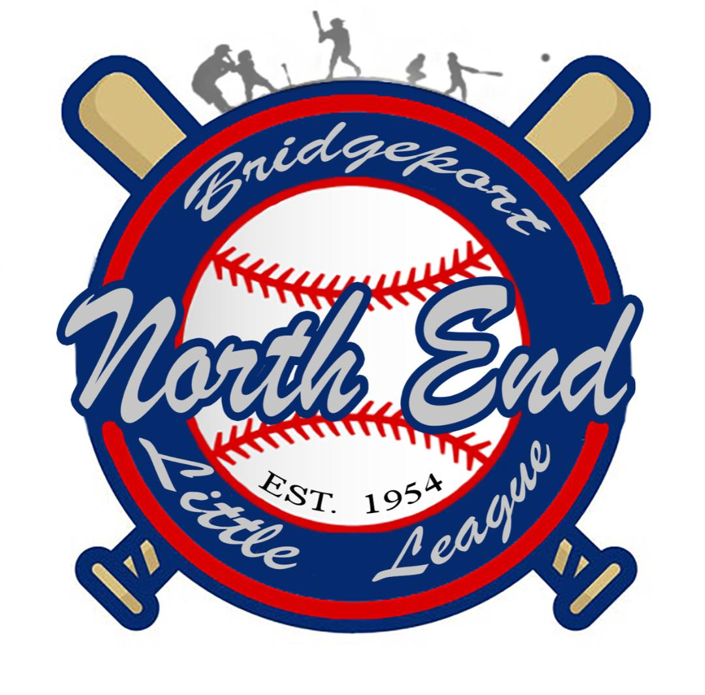
North End Little League
A Chartered League Since 1954
2024 Sponsor Packages

____ Corporate Sponsor (“GRAND SLAM” The Diamond Package) $2000.00
Banner mounted on all 3 scoreboards, 3x5 field banner on each of our 3 fields
advertisement on North End Little League website & social media, and a Thank you plaque
NEW THIS SEASON: banners will be on all 3 fields and an additional banner displayed at
snack-stand

____ Team Sponsor (“HOME-RUN” The Platinum Package) $700.00
Business name on team uniform; 3’ x 5’ sign at field; team plaque, business banner advertised
at opening day carried by the team during the walk out parade in front of all NELL family and invited
city officials & the Mayor.

____ All Star Sponsor (“NO HITTER” The Gold Package)
Name on team uniform/parent T-shirts & plaque with picture $600.00

____ Score Board Sponsor (“TRIPLE” The Silver Package)
Banner mounted on scoreboard 22”x33”
3 Scoreboards $500.00
1 Scoreboard $200.00

____ League Sponsor (“DOUBLE” The Bronze Package)
3’ x 5’ Sign at field $250.00

____ Social Media Booster (“SINGLE” The Iron Package)
Business advertisement on North End Little League social media
once a week every Friday during spring season $100.00

____ Donation $________
NELL BOARD
President | Jose Aviles
Vice President | Jose Torres
Treasurer | Shalimar Montanez
Recording Secretary | Jennise Rosado
Fundraising Coordinator  Safety Coordinator | Sonia Rodriguez  Shady Fequiere
Player Agent | Marques Brown

Nellbridgeport@yahoo.com * www.nellbpt.com * www.facebook.com/NELLBPT IG:@Northendlittleleague 203-520-7788

